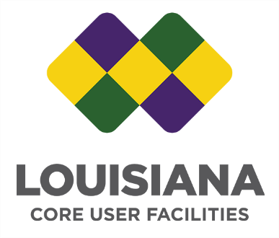
Vision
The Core User Facilities (CUF) will be a distributed, sustainable, and widely available resource conduit for supporting research and workforce development in science, technology, and engineering disciplines in Louisiana and the region.

Mission
- Provide access to sustainable, dedicated, state-of-the-art, experimental facilities for research and development in science and engineering.
- Develop and establish sustainable training and education programs based on the CUF material and human resources.
- Continuously incorporate new experimental capabilities to make state-of-the-art resources available to academic, industrial, and government customers.

Description of the CUF
The CUF is a network of cost-recovery facilities affiliated with Louisiana institutions of higher education that support experimental research. It is formulated as a conduit and a portal to experimental resources needed by academic, industry, or government users to support, research, and workforce development.

Membership Requirements
Additional cost-recovery-centers may join the CUF in the future, so long as they fulfill the following membership requirements:
- They are documented cost-recovery-centers with published user fee rates for use of resources and services.
- Their resources and services are openly available to users who are willing to pay the associated user fees. In situations where the instruments/services are highly specialized, it is understood that access may necessarily come in the form of a research collaboration with the relevant instrument scientists who have the requisite knowledge, expertise, and experience.
- The user fees charged to users from any Louisiana institution of higher education shall be discounted from the rates charged to non-academic users.
- They maintain, sustain and augment their experimental infrastructure and educational programs so that they are continuously and reliably available to users.
- They share data on annual activity, user demographics and distribution, and instrument acquisition when requested. [The data request may be for strengthening proposals or for annual reports on projects which made use of CUF research infrastructure.]
Inclusion of a relevant cost-recovery-center into the CUF will require an application documenting the fulfillment of the membership requirements above. The application will be reviewed by the CUF leadership team, who will make the final decision.

CUF Leadership Team
The CUF Leadership Team will consist of representatives of the institutions whose cost-recovery-centers are a part of the CUF. Each institution will be represented by as many members as the number of their cost-recovery-centers contributing to the CUF, preferably someone with management responsibilities for these cost-recovery-centers.

Application to Join Louisiana State-Wide

Core User Facilities (CUF)

- Name of Cost Recovery Center:
- Institutional Affiliation of the Cost Recovery Center:
- Center website URL:
- Center’s fee schedule URL (if not readily accessible from the Center website):
- Center Director Name, Title, Phone, and E-mail address:

- A brief description of the research capabilities provided by the Center including available technical staff support (250 words max):

On behalf of the cost-recovery center named above, I request that the center be added to the CUF ecosystem. I have reviewed the membership requirements and agree to abide by them. A copy of the published user fee schedule for the Center is included with this application.

For the Cost-Recovery Center: * | For CUF Leadership:
Signature: | Signature:
Name: | Name: Michael Khonsari, PhD
Title: | Title: Associate Commissioner for Research and Development, Louisiana Board of Regents
Date: | Date:
* The signatory must have the administrative authority to sign on behalf of the Center, particularly the authority to agree to charging internal rates for other CUF institution users.

